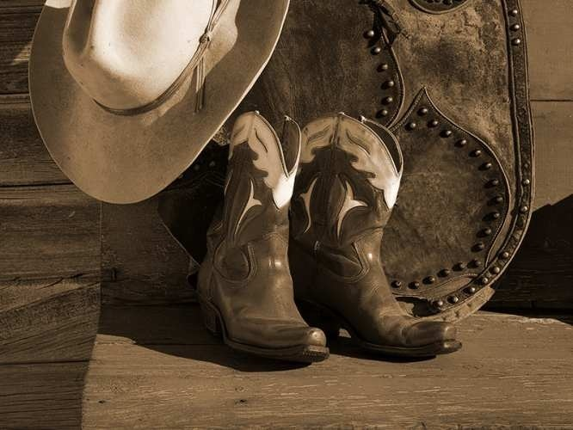

“Boots, Chaps & Cowboy Hats”
Estelline's 8th Annual
Rodeo & Reunion Days
June 16th & 17th 2017

A big THANK YOU to everyone that participated in Estelline's parade last year.
The parade will be on Saturday June 17th and starts at 10:00 AM like last year. The theme is “Boots, Chaps & Cowboy Hats” with the four categories to be judged. They are as follows: Best Western, Best Equestrian (this includes horses and/or horses and buggies), Best Antique Machinery/Tractors and the New Category of Best Auto (Older Cars and Pickups).
Line up for the parade will begin at 8:30 AM and will come down Main Street ending at 5th and Arthur. Please go North on 8th Street (on the East side of town) then West on Northridge Road for line up. Judging will start at 8:30 Am and End promptly at 9:30 Am. Anyone lining up after this time will not be judged. So Please be lined up by 9:30 AM or as close to it as possible. The Parade Committee welcomes horses, high school classes (past, present, and future), families, businesses, churches, dignitaries, clubs, bands, organizations, politicians, members of the military (past and present), American Legion Posts, motorcycles, cars and trucks, machinery and other usual parade entries.
The parade will be announced so please fill out the enclosed form and will be collected when you are in line prior to the start of the parade.
PLEASE LEAVE 3 CAR LENGTHS BETWEEN ENTRIES.
We have been advised by our insurance company that candy or any other items should NOT be thrown from the parade entries. To keep young ones safe, we are asking that adults walk along entries and throw their candy.
For more information contact Michaelle Gilbertson at (605)873-2088 or
by email mg.rodeo.16@gmail.com
This year we are adding a car show “Show & Shine” as part of the weekend fun. You are more than welcome to come enter the parade as well.
And if you or anyone you know would like to have a booth with our vendors you are more than welcome. For information on either of these please feel free to contact Trish Schwartz at (605)690-1299 or by email to estellinerodeovendors@gmail.com

We hope to see you all there!!!

