1st Annual Estelline Rodeo & Reunion

Bike/Car Show & Shine
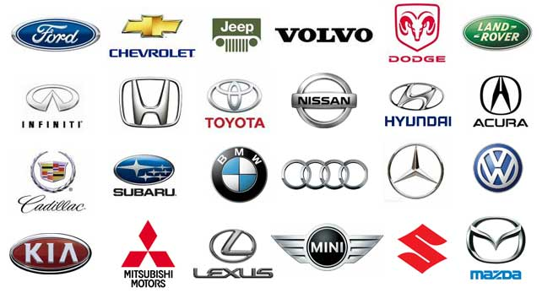
Date: June 17^{th,} 2017
Time: Immediately following parade-2:00 pm
Place: 200 Blk Main St. Estelline, SD
No Entry Fees!! Everyone Welcome! Free to the Public ~ Open to all Classic & Modern Motorcycles and Cars. We would love to have Estelline Alumni are strongly encouraged to bring cars! Contact Trish S. @ 605-690-1299 for the Show & Shine. Show off your pride & joy during parade. Contact Michaelle G. @ 873-2088. (Check the Estelline Rodeo Facebook page prior to the event in case of inclement weather.)

